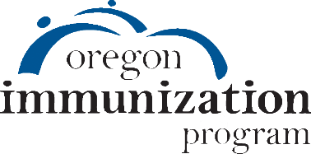

Oregon HPV Statewide Summit
Draft Agenda

Welcome 8:30 – 8:45

Survivor Perspective – Paul Aziz 8:45 – 9:00

The Current HPV Vaccination Landscape and Emerging Opportunities 9:00 – 10:00
Jesse Nodora, DrPH

HPV Vaccination: Just the Facts – Joan Watson-Patko, MSW 10:00 – 10:15

Break 10:15 – 10:30

Preventing HPV-Associated Cancers: Improving Teen HPV Vaccination in Oregon 10:30 – 11:15
Katrina Hedberg, MD,MPH

From National to Local: Building HPV Vaccination Capacity in Primary Care 11:15 – 11:45
Audrey Fine & Jenica Palmer, MPH

How to talk to Families and Patients about HPV Vaccine 11:45 – 12:15
Alanna Braun, MD,FAAP

Lunch & Networking 12:15 – 12:45

Transition to Breakout Sessions 12:45 – 1:00

- Breakout 1 1:00 – 1:50

- Breakout 2 2:00 – 2:50

- Breakout 3 3:00 – 3:50

Breakout Topics:

HPV Clinical Quality Improvement
Strategies to Increase Vaccine Uptake
Understanding Racial Disparities in HPV Vaccination
The Role of School Health Programs in HPV Prevention
HPV from a Youth Perspective: a Panel Discussion with OSBHA Student Health Advocates
Human Papillomavirus Infection and Oropharyngeal Cancer
Educating Care Providers on Multi-Disciplinary Oropharyngeal Cancer Treatment Delivery
HPV Impact: Surveillance of HPV-related cervical pre-cancers in Oregon, 2008-2016
Oregon Immunization Program HPV Perspectives on Provider Data and Provider Practice
You are the Key to Cancer Prevention – with CME

